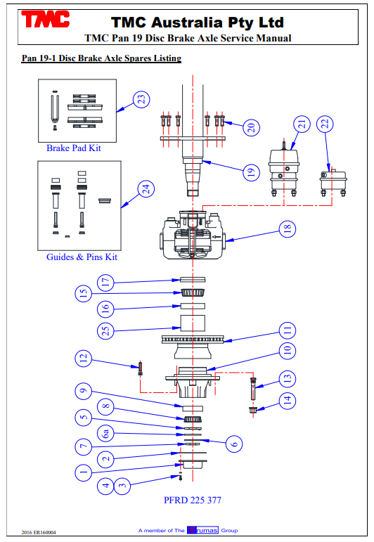
Item | TMC Aus Item Number = Description | TMC NZ Item Number
1 | 810146 Hubcap – grease
 | 810176 Hubcap – oil
2 | 810147 Hubcap gasket | AX01669
3 | 9HBM08125020 Hubcap stud M8 x 20 long
4 | 9SWM08 Hubcap spring washer
5 | 810124 Axle spindle adjusting nut | AX01671
6 | 810284 Lock tab washer | AX01673
6a | 810123 Axle spindle adjusting nut | AX01670
7 | 810125 Axle spindle lock nut | AX01672
8 | 81HM212049 Outer bearing cone | AX01695
9 | 81HM212011 Outer bearing cup | AX01694
10 | 820171 Hub 10 stud x 285 pcd
 | 820122 Hub 10 stud x 285 pcd ABS
 | 820176 Hub 10 stud x 335 pcd
 | 820127 Hub 10 stud x 335 pcd ABS
 | 820173 Hub 8 stud x 275 pcd | AX01665
 | 820124 Hub 8 stud x 275 pcd ABS
11 | 820105 Rotor – 377mm diameter | AX01667
12 | 9SHM14150060 Hub to rotor bolt M14 x 60 long Gr 10.9
13 | 810144 Wheel stud M22 x 100 long | AX01674
14 | 810145 Wheel nut M22 | AX01675
15 | 81HM218248 Inner wheel bearing cone | AX01697
16 | 81HM218210 Inner wheel bearing cup | AX01696
17 | 810135/02 Hub seal | AX01693
18 | 820107 Disc brake caliper assembly LH | AX01688
 | 820106 Disc brake caliper assembly RH | AX01687
19 | 820101 Axle beam assembly
20 | 9HBM16150050 Caliper attachment bolts M16 x 50 long Gr 10.9
21 | 820109 Brake chamber Type 16/24 universal
 | 820131 Brake chamber Type 16/16 universal
 | 820133 Brake chamber Type 12/16 universal
 | 820138 Brake chamber Type 14/16 universal
 | 820139 Brake chamber Type 14/24 universal
 | 820140 Brake chamber Type 20/16 universal
 | 820149 Brake chamber Type 20/24 universal
22 | 820132 Brake chamber Type 16 universal
 | 820134 Brake chamber Type 12 universal
 | 820135 Brake chamber Type 20 universal
 | 820136 Brake chamber Type 24 universal
22 | 820137 Brake chamber Type 22 universal
23 | 820737 Replacement brake pad set (per axle) | AX01689
24 | 820738 Replacement caliper guide pins and seals set (per caliper) | AX01692
 | 820736 Main piston & seal set with piston (per caliper) | AX01690
25 | Contact TMC - ABS Ring
** | Contact TMC - ABS sensor, sensor bush and block & pole wheel

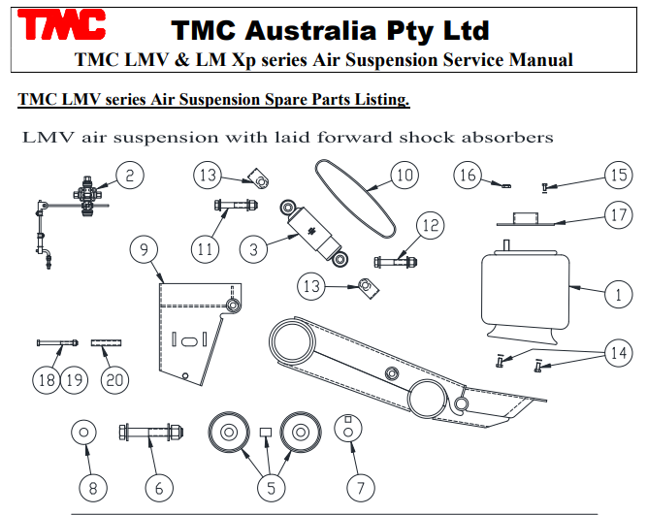
Item | TMC Aus Item Number = Description | TMC NZ Item Number
1 | 626104 Air spring 1R12-642 | AX01676
 | 626499 Air spring 1R12-664 (330 ride height only)
2 | 625226 Levelling valve assembly
3 | 626500 Shock absorber M24 (laid forward shock absorber) | AX01681
5 | 626117SB Pivot bushes c/w joining sleeves – one axle | AX01677
6 | 626122SB Pivot bolt c/w nut and washer | AX01678
7 | 626123 Hanger alignment washer | AX01679
8 | 626126 Hanger pivot washer | AX01680
9 | Refer TMC Front hanger assembly
10 | 626134-345-3 Catch strap (orange 3 ply) (laid forward shock absorber) | AX01682
11 | 626527SB Shocker bolt assembly top M24 x 270 long | AX01685
12 | 626528SB Shocker bolt assembly bottom M24 x 250 long | AX01686
13 | 626501/01 & /02 Catch strap clip M24 (one pc. 01 & 02 per shock) | AX01683
14 | 9HB1/2UNC1.25 Airbag bolt bottom ½”UNC x 1.25” long
15 | 9HB3/8UNC1.00 Airbag top bolt 3/8” UNC x 1” long
16 | 9LNT3/4UNF Airbag top mounting nut ¾” UNF nyloc
17 | Refer TMC Airbag top mounting bracket
18 | 9HBM12175140 Hex bolt M12 x 140
19 | 9LNM12 Nyloc nut M12
20 | 626159 Spacer tube

